**VINYL CABLE LUG END CAPS**

Made from PVC material, the End Caps are used to protect wire and cable ends.

There are six colour options with twenty dimensions for various cable sizes.

Material: PVC

Standard colours **:** Red, Yellow, Blue, Black, Green

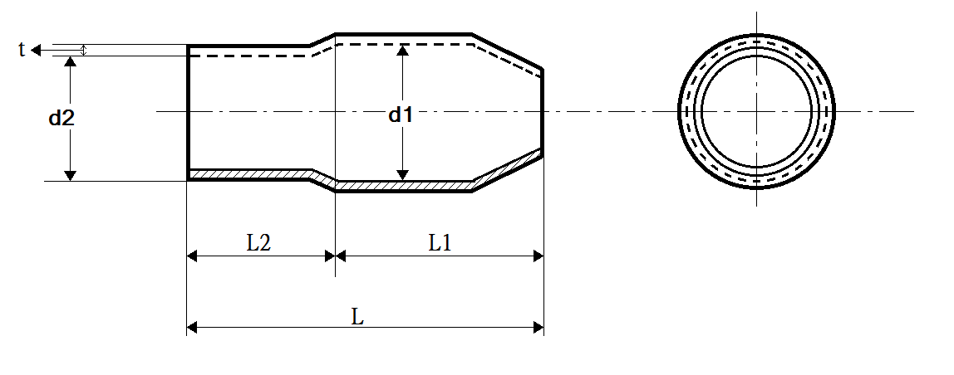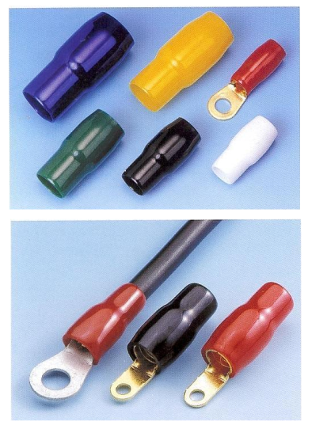

|  |  |  |  |  |  |  |  |  |
| --- | --- | --- | --- | --- | --- | --- | --- | --- |
| **Item No.** | **Applicable Wire** | **d1** | **d2** | **L** | **L1** | **L2** | **t** | **Per Pack / Unit** |
| **Ø** | **Ø** | **±2** | **±1** | **±1** | **±0.2** |
| IAEC-V-1.25 X | 1.5 MM2 | 3.3 | 3.1 | 15.0 | 7.0 | 8.0 | 0.6 | 100 PCS |
| IAEC-V-2 X | 2.5 MM2 | 4.5 | 3.7 | 16.0 | 8.0 | 8.0 | 0.7 | 100 PCS |
| IAEC-V-3.5 X | 4 MM2 | 5.7 | 4.1 | 18.0 | 9.0 | 9.0 | 0.8 | 100 PCS |
| IAEC-V-5.5 X | 6 MM2 | 5.7 | 5.2 | 20.0 | 10.0 | 10.0 | 0.8 | 100 PCS |
| IAEC-V-8 X | 10 MM2 | 7.2 | 6.2 | 21.0 | 11.0 | 10.0 | 1.0 | 100 PCS |
| IAEC-V-14 X | 16 MM2 | 10.0 | 8.0 | 28.0 | 15.0 | 13.0 | 1.1 | 100 PCS |
| IAEC-V-22 X | 25 / 35 MM2 | 12.0 | 9.5 | 29.0 | 15.0 | 14.0 | 1.2 | 100 PCS |
| IAEC-V-38 X | 50 MM2 | 14.0 | 11.8 | 34.0 | 17.0 | 17.0 | 1.4 | 100 PCS |
| IAEC-V-60 X | 70 MM2 | 17.0 | 13.9 | 42.0 | 22.0 | 20.0 | 1.5 | 100 PCS |
| IAEC-V-80 X | 95 MM2 | 19.5 | 16.0 | 46.0 | 25.0 | 21.0 | 1.5 | 50 PCS |
| IAEC-V-100 X | 120 MM2 | 22.0 | 18.0 | 55.0 | 31.0 | 24.0 | 1.7 | 50 PCS |
| IAEC-V-125 X | 150 MM2 | 24.4 | 20.0 | 60.0 | 32.0 | 28.0 | 1.8 | 50 PCS |
| IAEC-V-150 X | 185 MM2 | 26.0 | 22.0 | 65.0 | 34.0 | 31.0 | 1.8 | 50 PCS |
| IAEC-V-200 X | 240 MM2 | 32.2 | 24.0 | 69.0 | 38.0 | 31.0 | 2.0 | 50 PCS |
| IAEC-V-250 X | 300 MM2 | 37.5 | 26.5 | 75.0 | 42.0 | 33.0 | 2.0 | 50 PCS |
| IAEC-V-325 X | 400 MM2 | 37.5 | 30.0 | 75.0 | 42.0 | 33.0 | 2.0 | 25 PCS |
| IAEC-V-400 X | 500 MM2 | 45.1 | 37.5 | 83.0 | 43.0 | 40.0 | 2.0 | 25 PCS |
| IAEC-V-500 X | 630 MM2 | 48.2 | 40.2 | 85.0 | 43.0 | 42.0 | 2.0 | 25 PCS |

Note:

1. All dimensions are in mm.